Olaf Scholz and Jonas Gahr Støre in conversation with entrepreneurs
Hannover Messe: The Chancellor of Germany and the Norwegian Prime Minister visit Rittal and Eplan
Herborn, 23 April 2024
Industry is in the midst of a transformation: Digitalisation, the energy transition and sustainability must be achieved. What it takes to do this: Large-scale, quick and efficient infrastructure expansion thanks to standardisation. Rittal and Eplan have now shown German Chancellor Olaf Scholz and Norwegian Prime Minister Jonas Gahr Støre live and in colour at the Hannover Messe that this calls for a rethink and the companies explained how this can work. It would no longer be possible to solve the major challenges through individual products or companies but through fully integrated and optimised value-added processes — from panel building and switchgear manufacturing to smart production.
Chancellor Scholz was visibly impressed as he walked around the Eplan and Rittal exhibition stand. Welcomed by Prof. Friedhelm Loh, owner and CEO of the Friedhelm Loh Group, and Markus Asch, CEO of Rittal International and Rittal Software Systems, Chancellor Olaf Scholz and Norwegian Prime Minister Jonas Gahr Støre made themselves familiar with the wide range of products and services offered by the innovation leaders. The companies impressively showed how to master the major transformation processes in industry by combining software and hardware and through consistent standardisation.

Markus Asch made it clear: “The transformation of industry now requires, above all, a rapid and efficient expansion of the infrastructure, even though capacities and expertise are limited.” Standards and consistent data, available across the entire value chain, were the key. Eplan, Rittal and Rittal Automation Systems are specialists in this field: “With Eplan software, our customers in panel building and switchgear manufacturing can create a complete digital twin of an enclosure right at the beginning of the process, including all the components installed within it. This data is then available throughout the rest of the process, from design and engineering to manufacturing and machining to operation.” This makes the process up to 85% faster and more efficient, either through automation or even via software-assisted handling, which even untrained specialists can carry out, such as “lawyers, for example,” as the Chancellor (and law graduate) added with a smile.
What was experienced here in practice using the example of panel building and switchgear manufacturing is also a principle of action for the entire industry, right down to the smart factory: “You can only optimise if you create transparency throughout all processes. If you make energy consumption transparent and correlate it with the manufacturing processes, you can produce much more energy-efficiently and establish the conditions for sustainability reporting,” the CEO added. Digitalisation is, therefore, a decisive lever for the energy transition, and sustainability is the framework for shaping digitalisation.

The integrated technological expertise of Rittal and Eplan with their sister companies Cideon and German Edge Cloud, which ranges from product design, and plant and mechanical engineering to digitisation in manufacturing, shows how digitisation can also be achieved across sectors and ecosystems.

“Thank you very much for visiting us at our booth,” said owner Professor Loh as the visit came to an end: “We wanted to show that the companies in the industry are enablers, especially in times like these.”

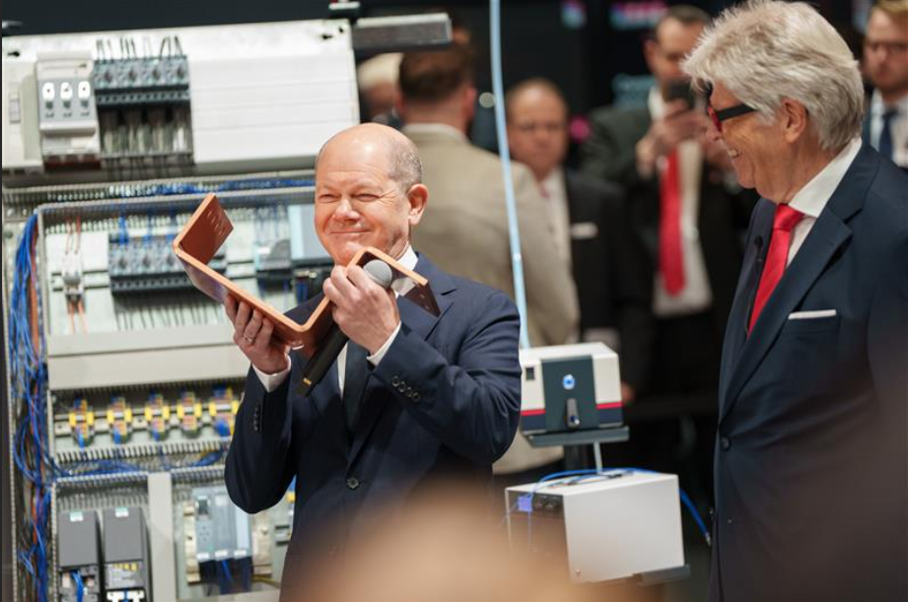 |  | 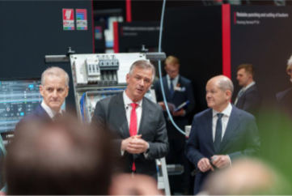
Figure 1  German Chancellor Olaf Scholz inspects a copper rail for power distribution in the presence of Professor Friedhelm Loh, owner and CEO of the Friedhelm Loh Group. |  | Figure 2  Markus Asch (centre), CEO of Rittal International and Rittal Software Systems, presents Rittal and Eplan’s joint trade show presence to Norwegian Prime Minister Jonas Gahr Støre and German Chancellor Olaf Scholz.
Figure 3
The companies impressively showed how to master the major transformation processes in industry by combining software and hardware. (Source: RonnyHartmann)
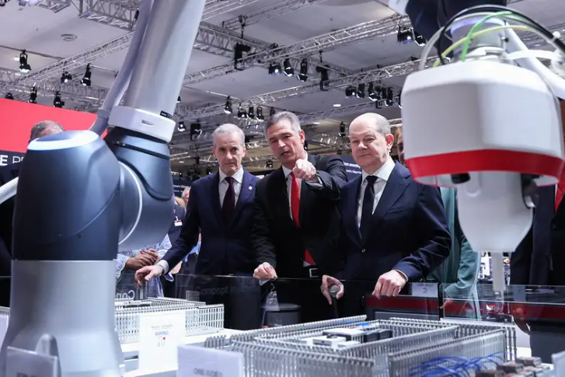

May be reproduced free of charge. Please name Rittal GmbH & Co. KG or picture alliance Rittal GmbH & Co. KG for picture 3 or Ronny Hartmann for picture 4 as the source.
.

Rittal and Eplan

Rittal is a leading global supplier of enclosure systems, automation and infrastructure with its industrial, IT, energy and power, cooling and service units. Rittal products and solutions are used in over 90% of global industries – standardised, customised, and always of the very best quality.
Our approach and methodology: Rittal, Rittal Software Systems (Eplan, Cideon and German Edge Cloud) and Rittal Automation Systems (RAS, Ehrt, Alfra) combine their hardware and software expertise to streamline, optimise and digitalise processes across the entire value chain for our customers including their IT infrastructure – from control and switchgear construction, machine building to factory operators or the energy sector.
Our delivery promise: Rittal standard products are delivered in Germany within 24 hours, and within 48 hours throughout Europe.
Customer focus
Improving efficiency and increasing productivity through automation and digitalisation is one of the biggest challenges for our customers. This requires in-depth knowledge and expertise, the combination of hardware and software, and cross-sector networking. We are convinced that creating and connecting data rooms is crucial to the success of industrial transformation. And that is exactly our speciality and field of competence.
Eplan and Rittal are driving the development of the digital automation twin, making data accessible and useable in operations as well. Cideon is improving data consistency in the digital product twin context with its CAD/CAM, PDM/PLM and product configuration expertise. German Edge Cloud’s ONCITE Digital Production System (DPS) makes production process data transparent, enabling it to be optimised – right through to energy management using digital production twins.
Sustainability
Environmental and climate protection, social commitment and ethical corporate management are a given for Rittal. We take our responsibility for a sustainable future seriously. Our approach to resource management and conservation involves continuous improvement of our own production processes and ensuring that our products have the lowest possible Product Carbon Footprint. Our solutions support our customers in achieving their own climate targets.
Family business and global player
Founded in 1961, Rittal is the largest company in the owner-operated Friedhelm Loh Group. The group operates worldwide, with more than 12 production sites and over 95 international subsidiaries. It has more than 12,100 employees and posted revenues of 3 billion euros in fiscal 2023. In 2023, the Friedhelm Loh Group was presented with the “Best Place to Learn” and “Employer of the Future” awards. In 2024, Rittal was awarded the Top 100 Seal as one of Germany’s most innovative medium-sized companies for the third time in a row.
For more information, visit www.rittal.com and www.friedhelm-loh-group.com.

Corporate Communications
Dr. Carola Hilbrand Rittal GmbH & Co. KG
Corporate & Brand Communications Auf dem Stützelberg
Tel.: 02772/505-2527 35745 Herborn
hilbrand.c@rittal.de www.rittal.com


Follow us:

